DAY 1 — Data Analytics & Data Science Fundamentals
1) Task Day: Friday, Date :11/09/2026
2) Task Description: To understand the basic concepts of Data, Data Analytics, Data Science, types of analytics, and the complete Data Science lifecycle.
3) 2) Task Elaboration: 1) Learned the definitions, types of analytics, real-world examples, and technologies used in Data Analytics and Data Science. 2) Created a workflow diagram showing the complete data project lifecycle from Business Problem to Deployment/Reporting.
4) Task Screenshot / Proofs:
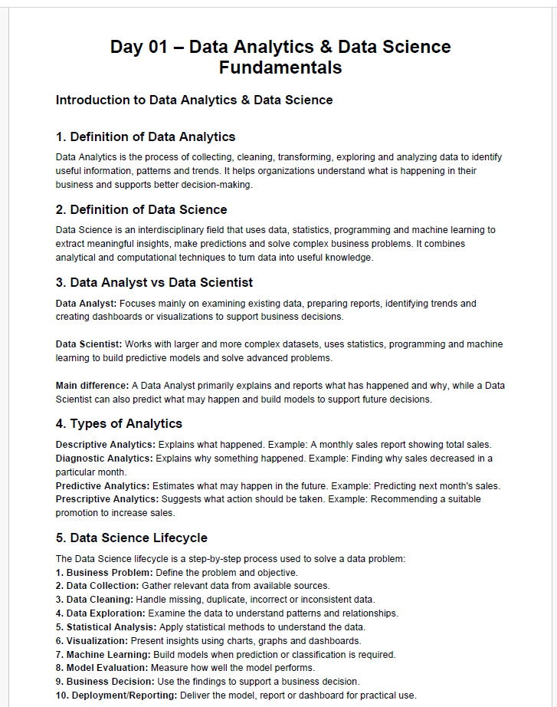
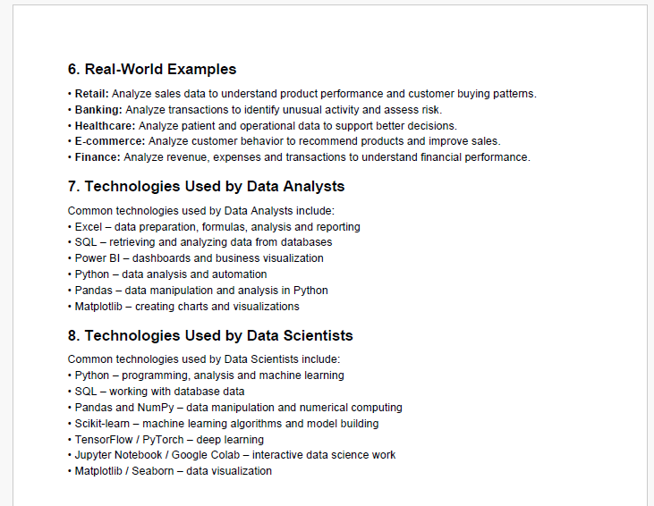
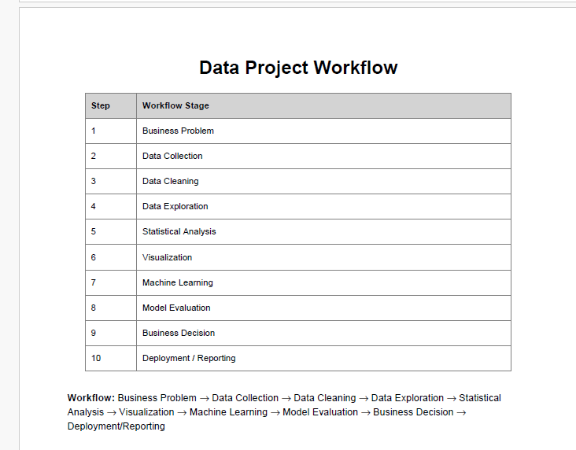
DAY 2 -:Python Basics :-
1) Task Day: Friday, Date :11/09/2026
2) Task Description: To learn Python basics, including variables, data types, operators, conditions, and loops, and create 10 basic Python programs.
3) 2) Task Elaboration: 1) Developed Python programs such as a calculator, even/odd checker, grade calculator, factorial, and Fibonacci series. 2) Practiced Python logic, conditions, loops, and different inputs, and tested the programs with outputs.

4) Task Screenshot / Proofs:
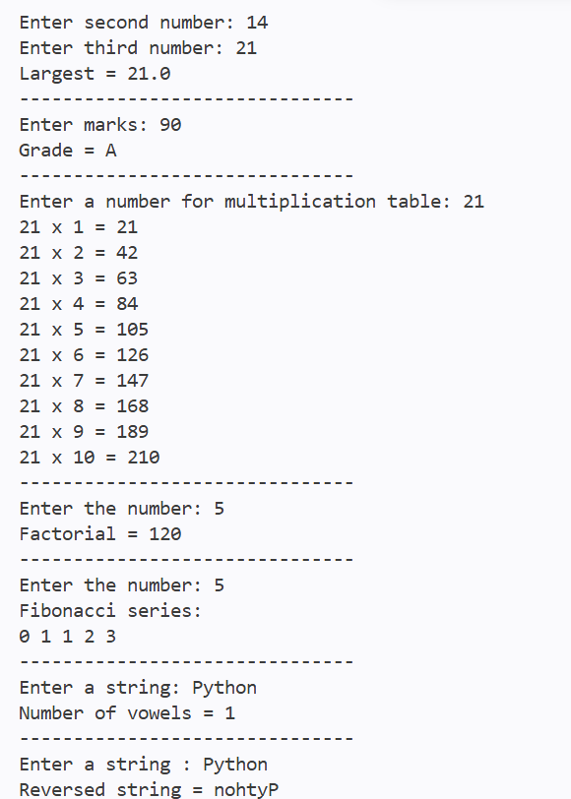
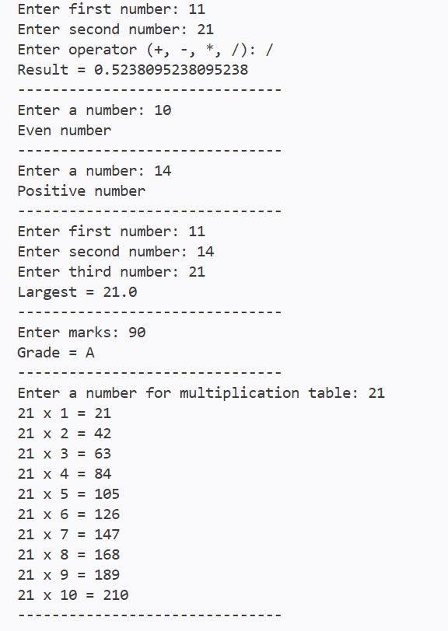

DAY 3 -: Functions + Advanced Python Basics:-
1) Task Day: Saturday, Date :12/09/2026
2) Task Description: To learn Python functions, parameters, return values, lambda, map(), filter(), comprehensions, exception handling, and modules.
3) 2) Task Elaboration: 1) Created reusable functions to calculate average, maximum, minimum, grade, and percentage using Python. 2) Developed a Python program using all functions and practiced writing readable, reusable, and maintainable code.
4) Task Screenshot / Proofs:
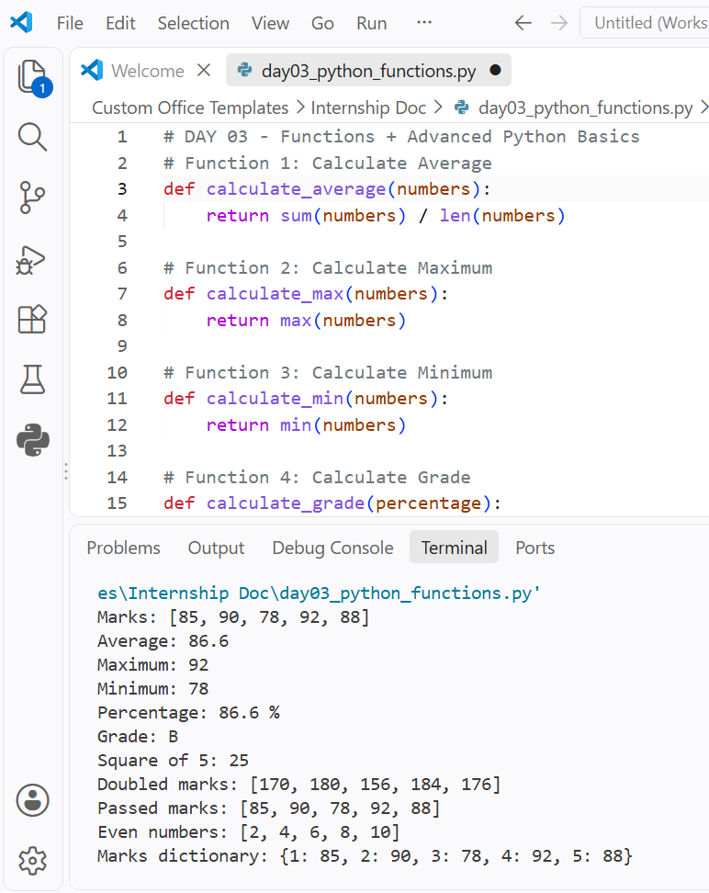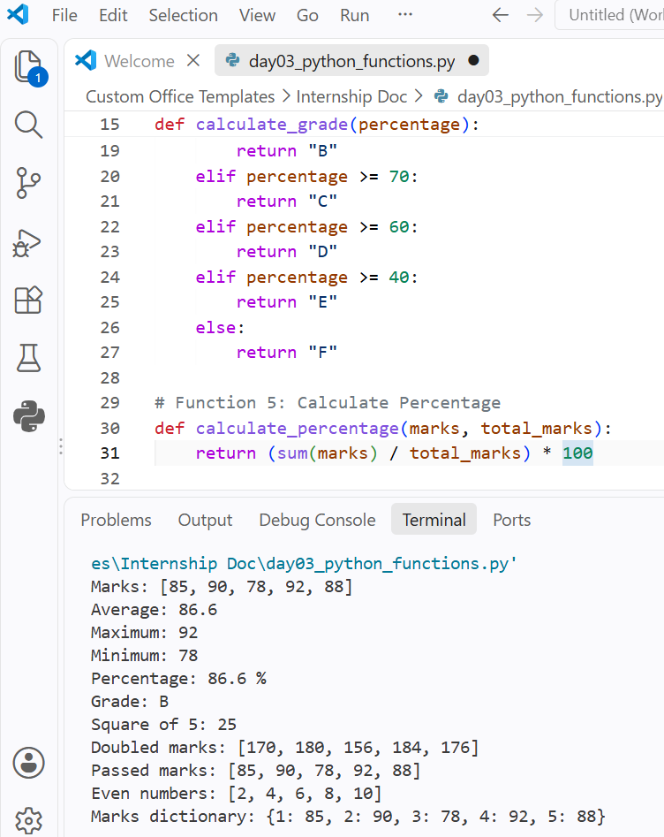

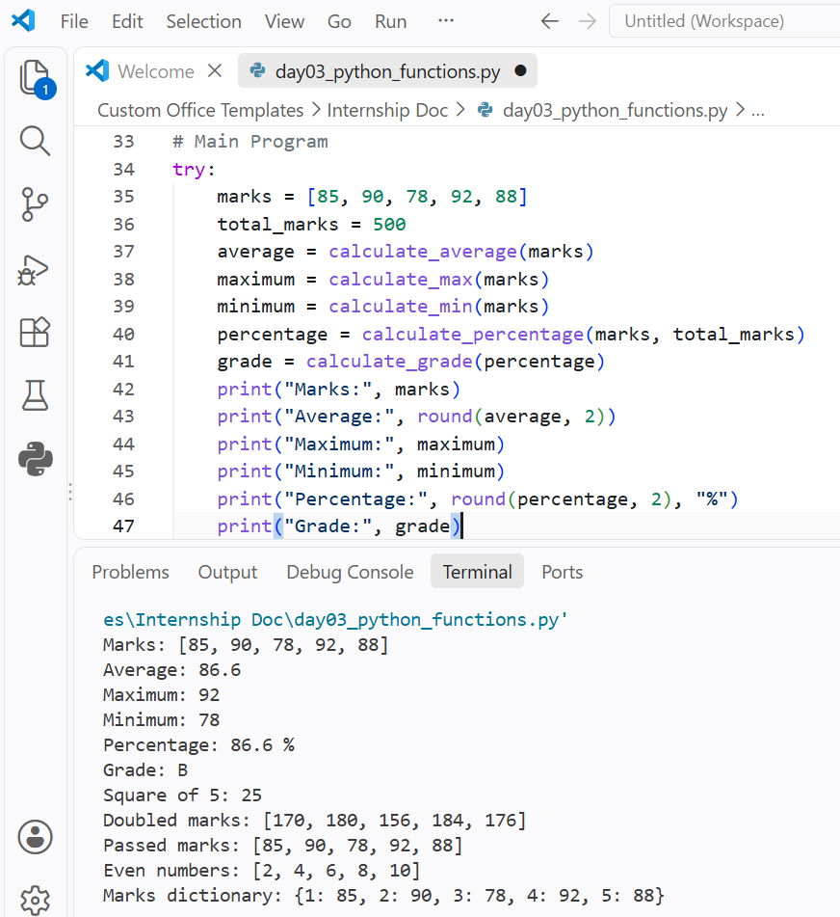
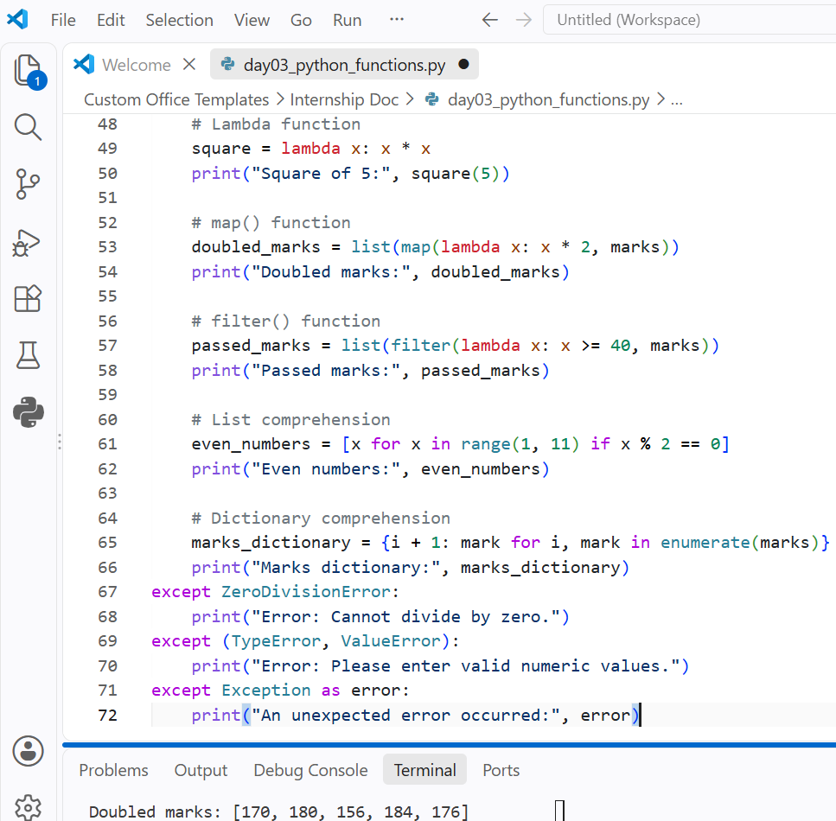

DAY 4 -: NumPy :-
1) Task Day: Tuesday, Date :15/09/2026
2) Task Description: Learn NumPy and perform numerical operations using one-dimensional and two-dimensional arrays, including sales data aggregation, reshaping, and matrix multiplication
3) 2) Task Elaboration: 1) In this task, I learned the fundamentals of NumPy 2) I practiced creating arrays, understanding dimensions and shape, indexing, slicing, reshaping, and arithmetic operations.
4) Task Screenshot / Proofs:
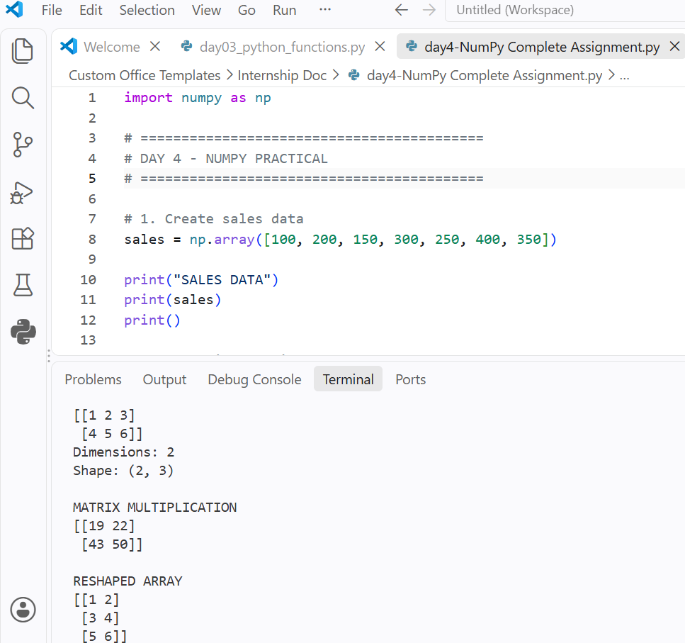
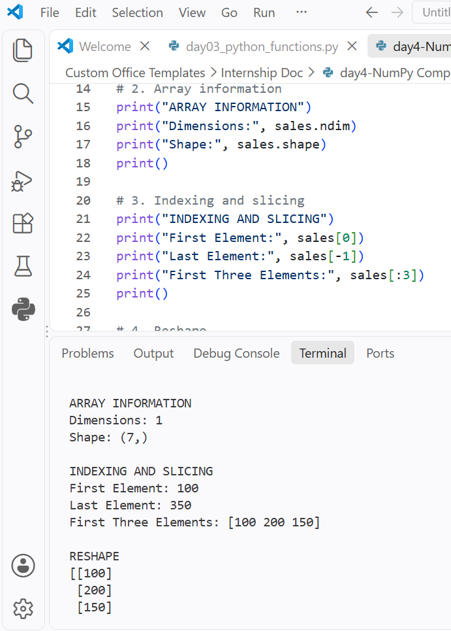
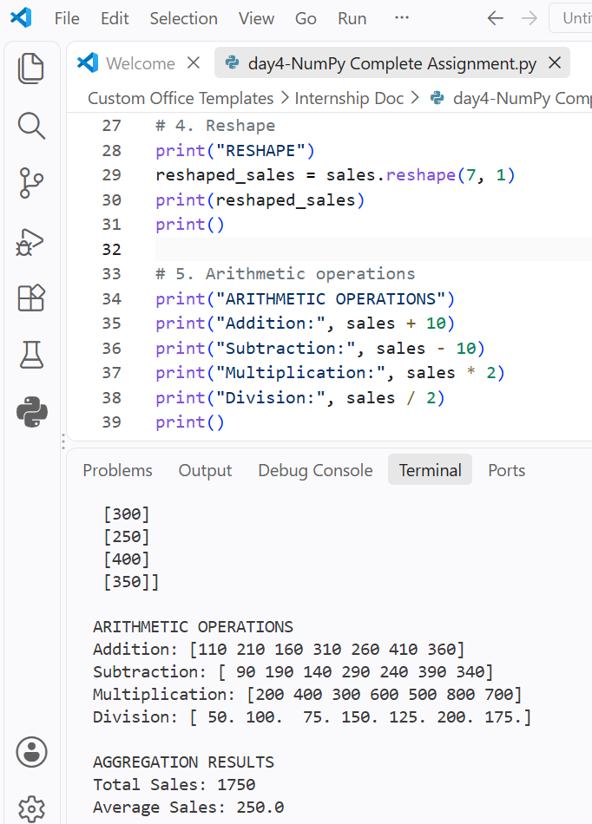
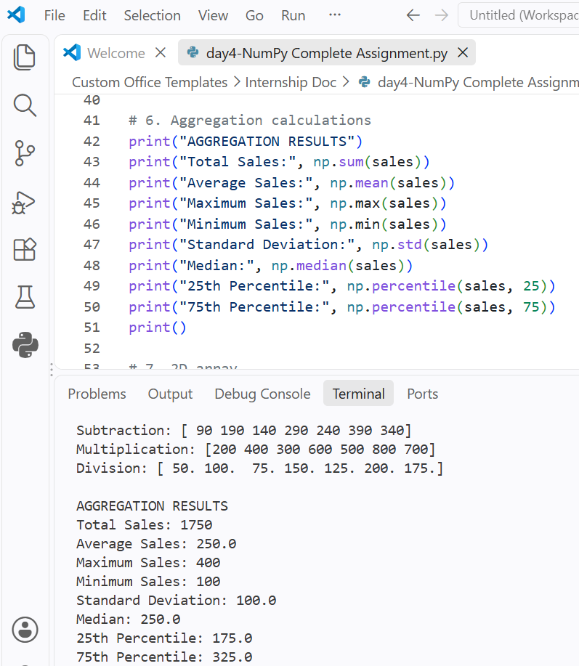
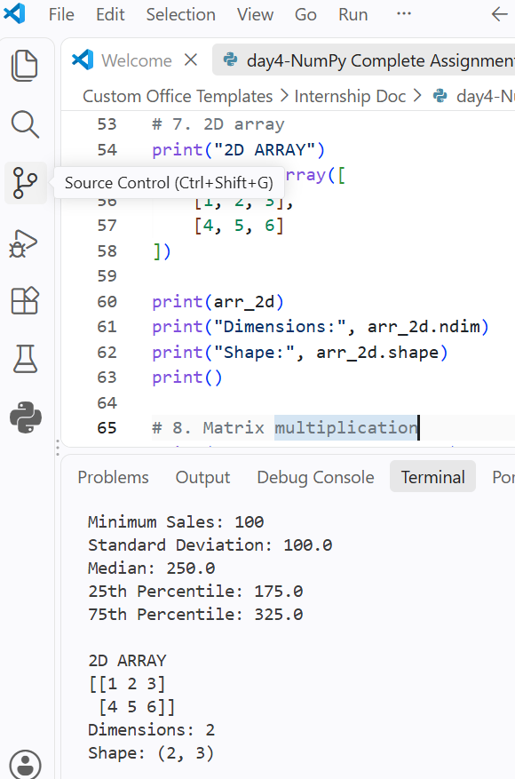
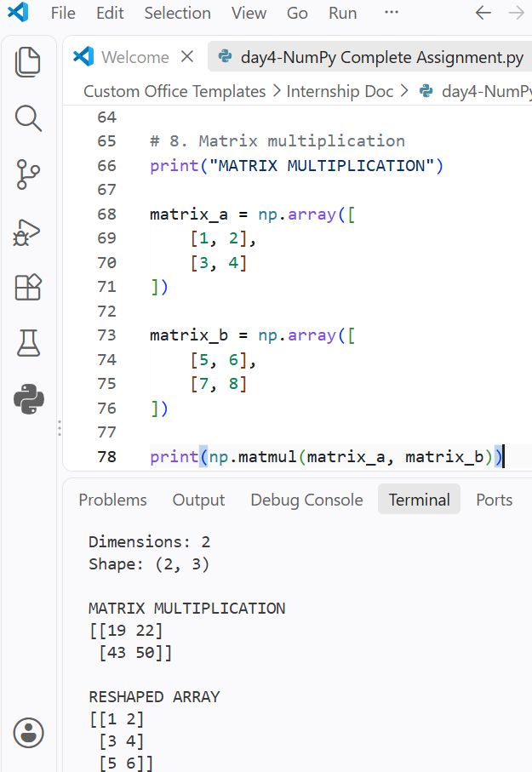

DAY 5 -: Pandas Basics Task :-
1) Task Day: Wednesday, Date :16/09/2026
2) Task Description: Learn the basics of Pandas in Python, including Series, DataFrame, CSV file handling, and basic data inspection methods.
3) 2) Task Elaboration: 1) In this task, I learned how to use the Pandas library for data analysis and data manipulation. 2) I created a Pandas Series and DataFrame and loaded employee data from a CSV file using read_csv()
4) Task Screenshot / Proofs:
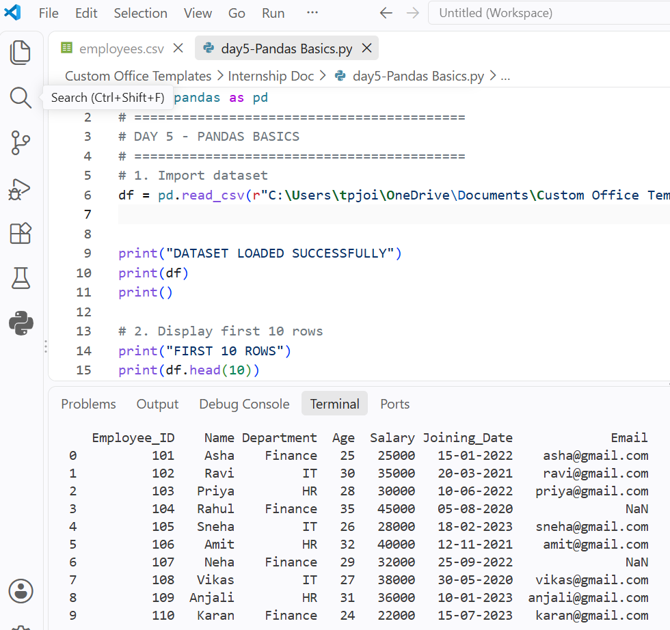
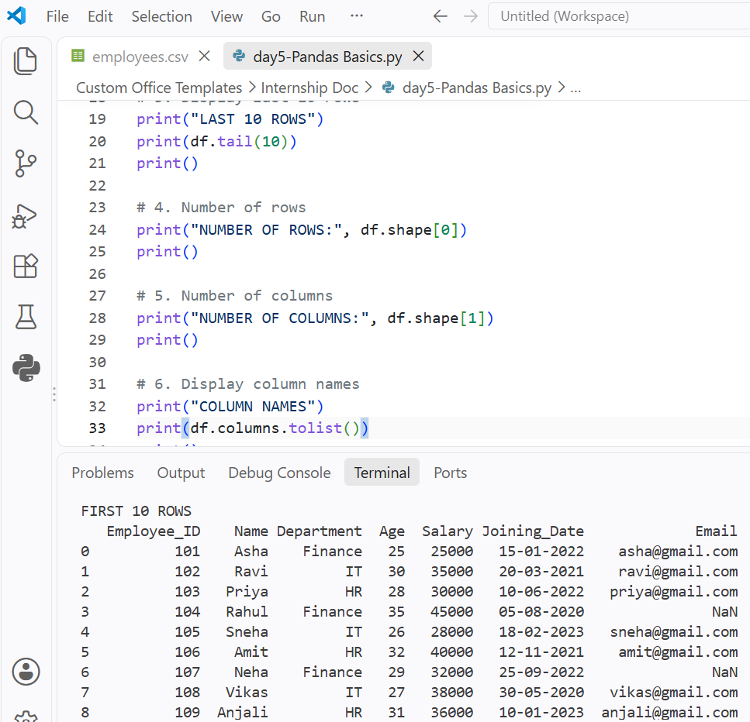
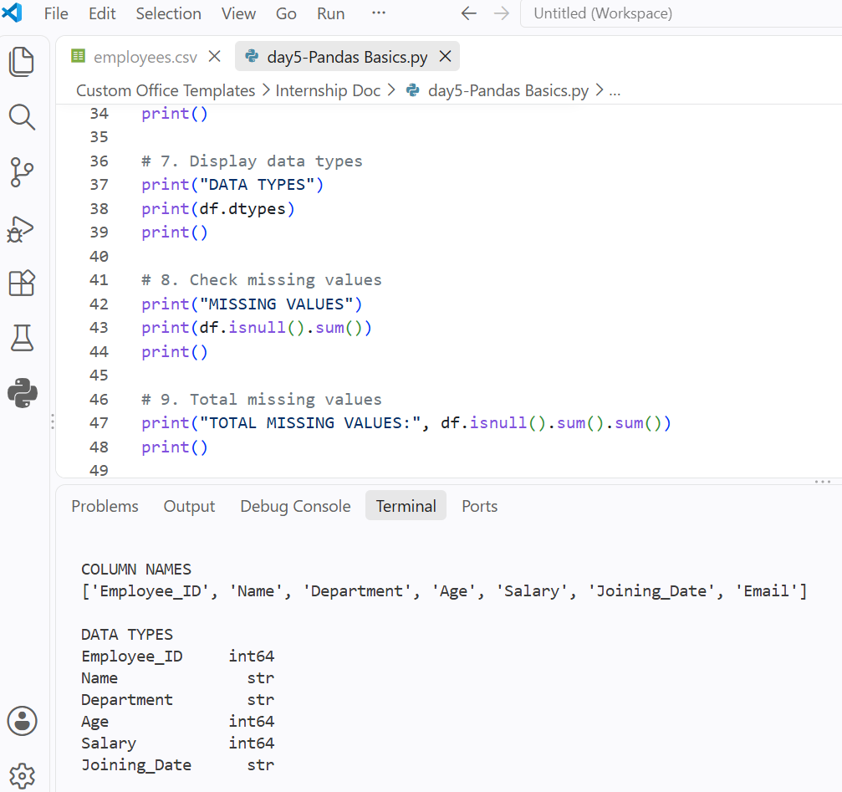
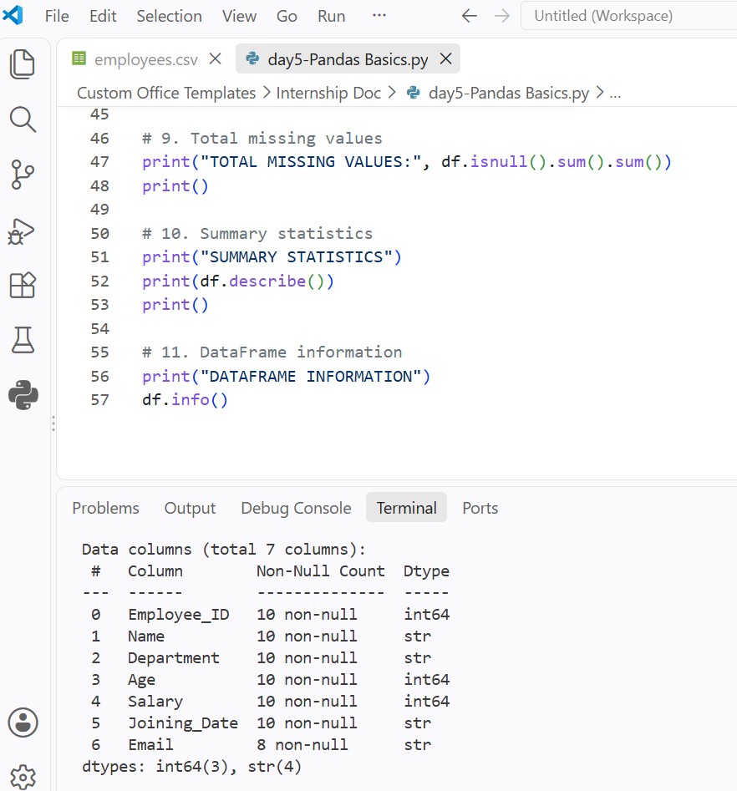

DAY 6 —-: Data Cleaning :-
1) Task Day: Thursday, Date :17/09/2026
2) Task Description: Performed data cleaning on a messy customer dataset using Python and Pandas. Identified and handled missing values, duplicate records, incorrect data types, inconsistent text, and abnormal values.
3) Task Elaboration: 1) Loaded the customer dataset using Pandas and analyzed the data for missing values, duplicate records, incorrect data types, and inconsistent values.
2) Cleaned the dataset by standardizing text, converting data types, removing duplicates, handling missing values, and identifying and correcting abnormal/outlier values. Finally, saved the cleaned dataset as a new CSV file.
4) Task Screenshot / Proofs:
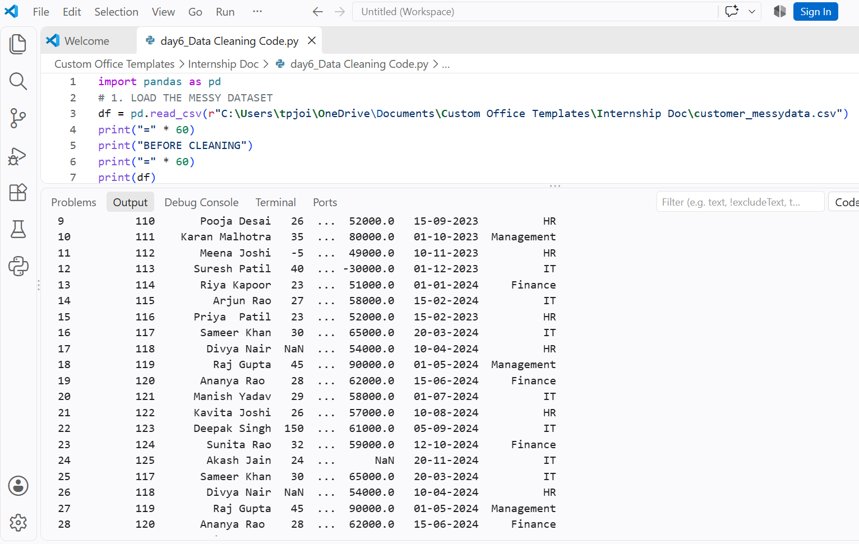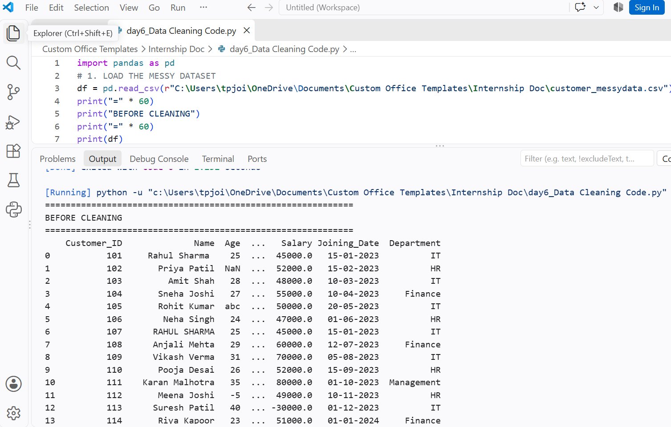
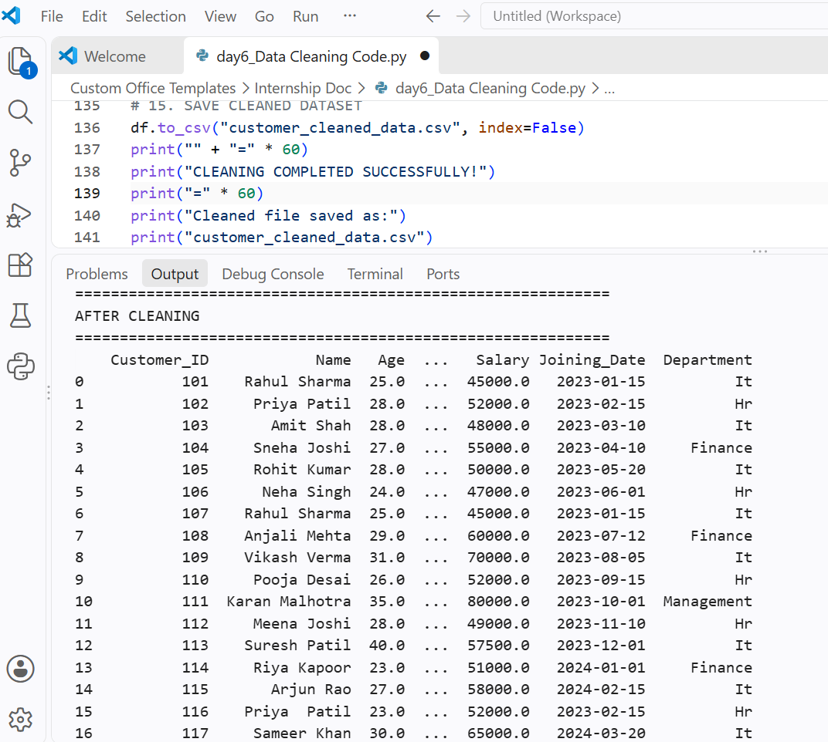
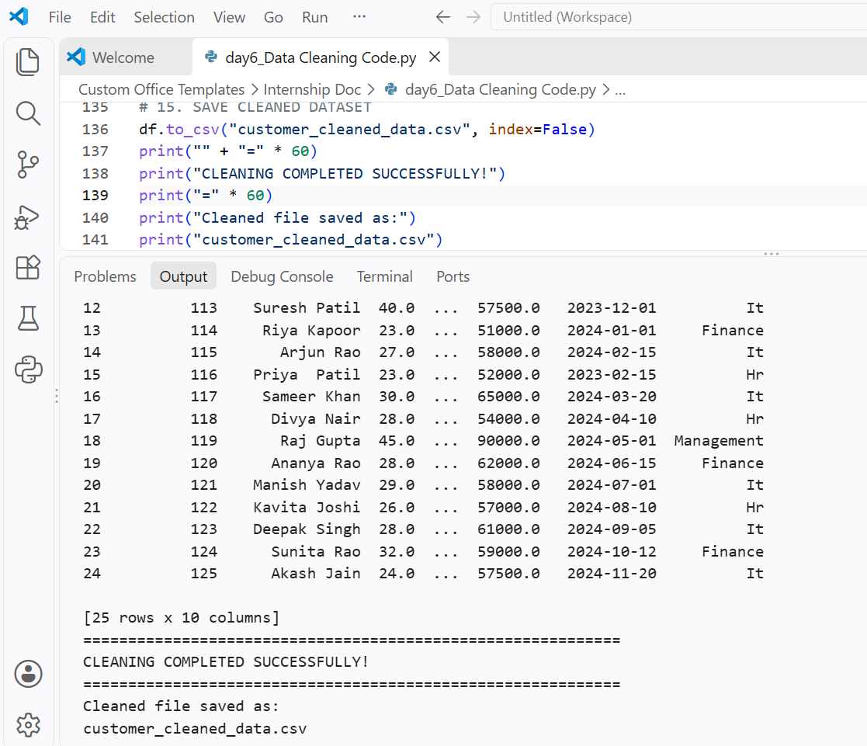

DAY 7 — -: SQL Fundamentals :-
1) Task Day: Friday, Date :18/09/2026
2) Task Description: Learned SQL fundamentals by creating a database with customers, products, and orders tables. Performed data retrieval and analysis using SQL queries.
3) Task Elaboration:1) Created a SQL database with customers, products, and orders tables using primary keys and foreign keys, and inserted sample data.
2) Wrote and executed 30 SQL queries using SELECT, WHERE, ORDER BY, GROUP BY, HAVING, DISTINCT, CASE, JOIN, SUM(), AVG(), and COUNT() to analyze customers, products, orders, and sales.
4) Task Screenshot / Proofs: 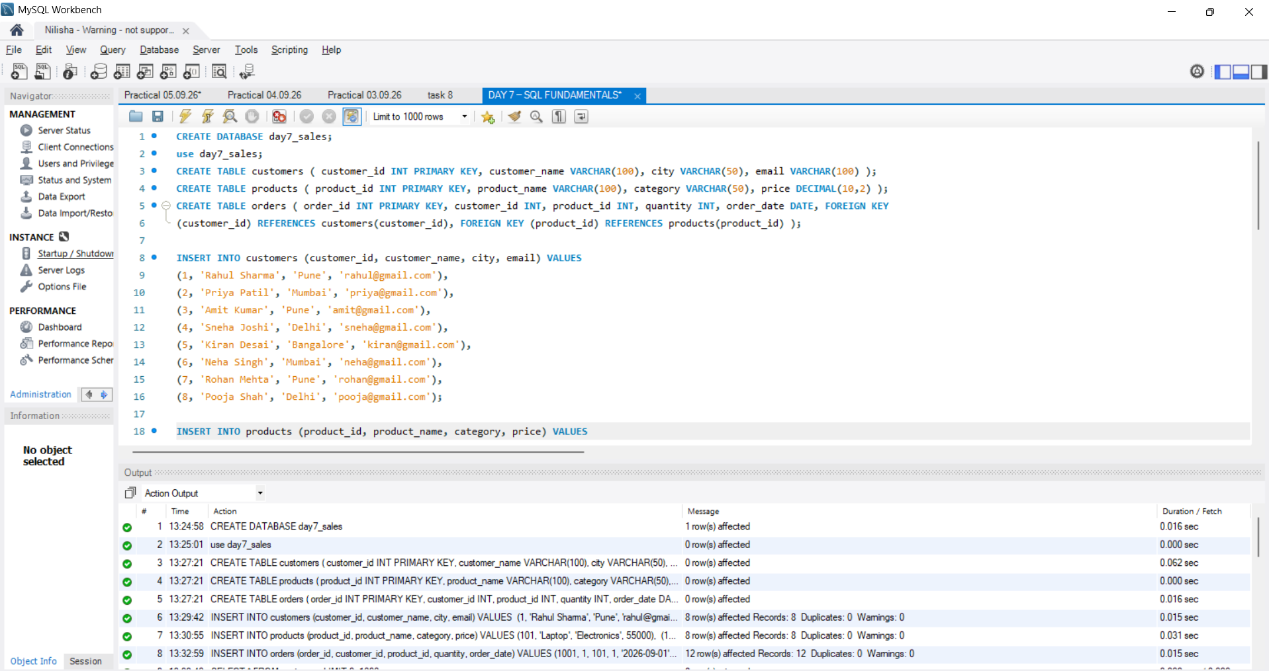
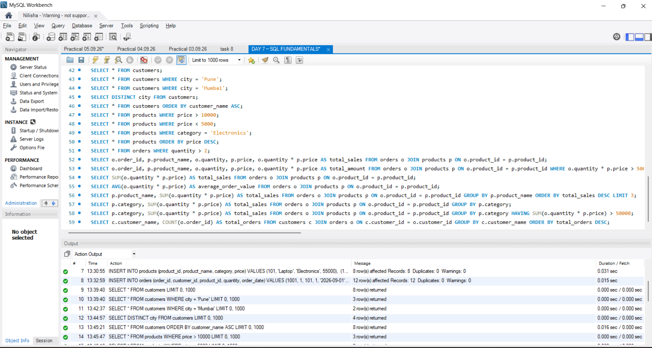
DAY 8 — :- Advanced SQL Task -:
1) Task Day: Saturday, Date :19/09/2026
2) Task Description: Learn and implement advanced SQL concepts such as JOINs, Subqueries, CTEs, and Window Functions. Solve analytical problems including top 3 customers, top 3 products per category, customer ranking, monthly revenue, previous month's revenue, month-over-month growth, and employee salary ranking using SQL queries.
3) 2) Task Elaboration:1). Learned advanced SQL concepts, including JOINs, Subqueries, CTEs, and Window Functions. 2). Practiced 20 SQL queries for customer ranking, product analysis, monthly revenue, and employee salary ranking.
4) Task Screenshot / Proofs:
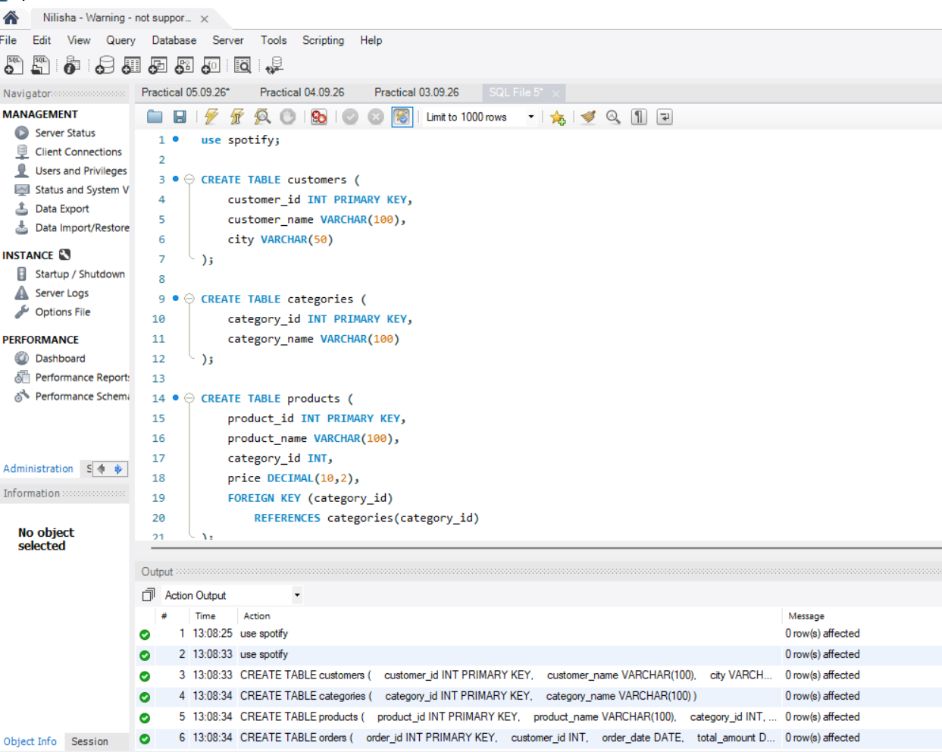
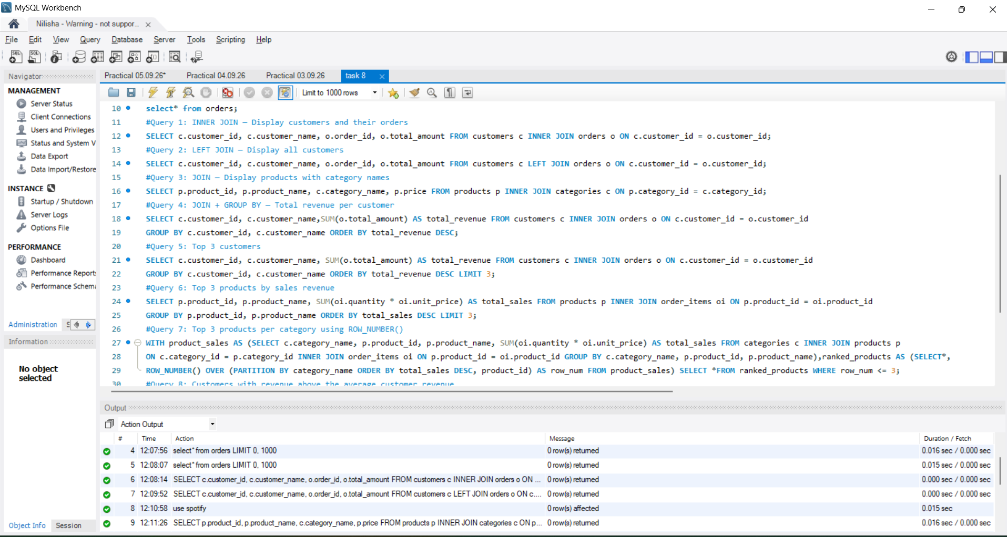

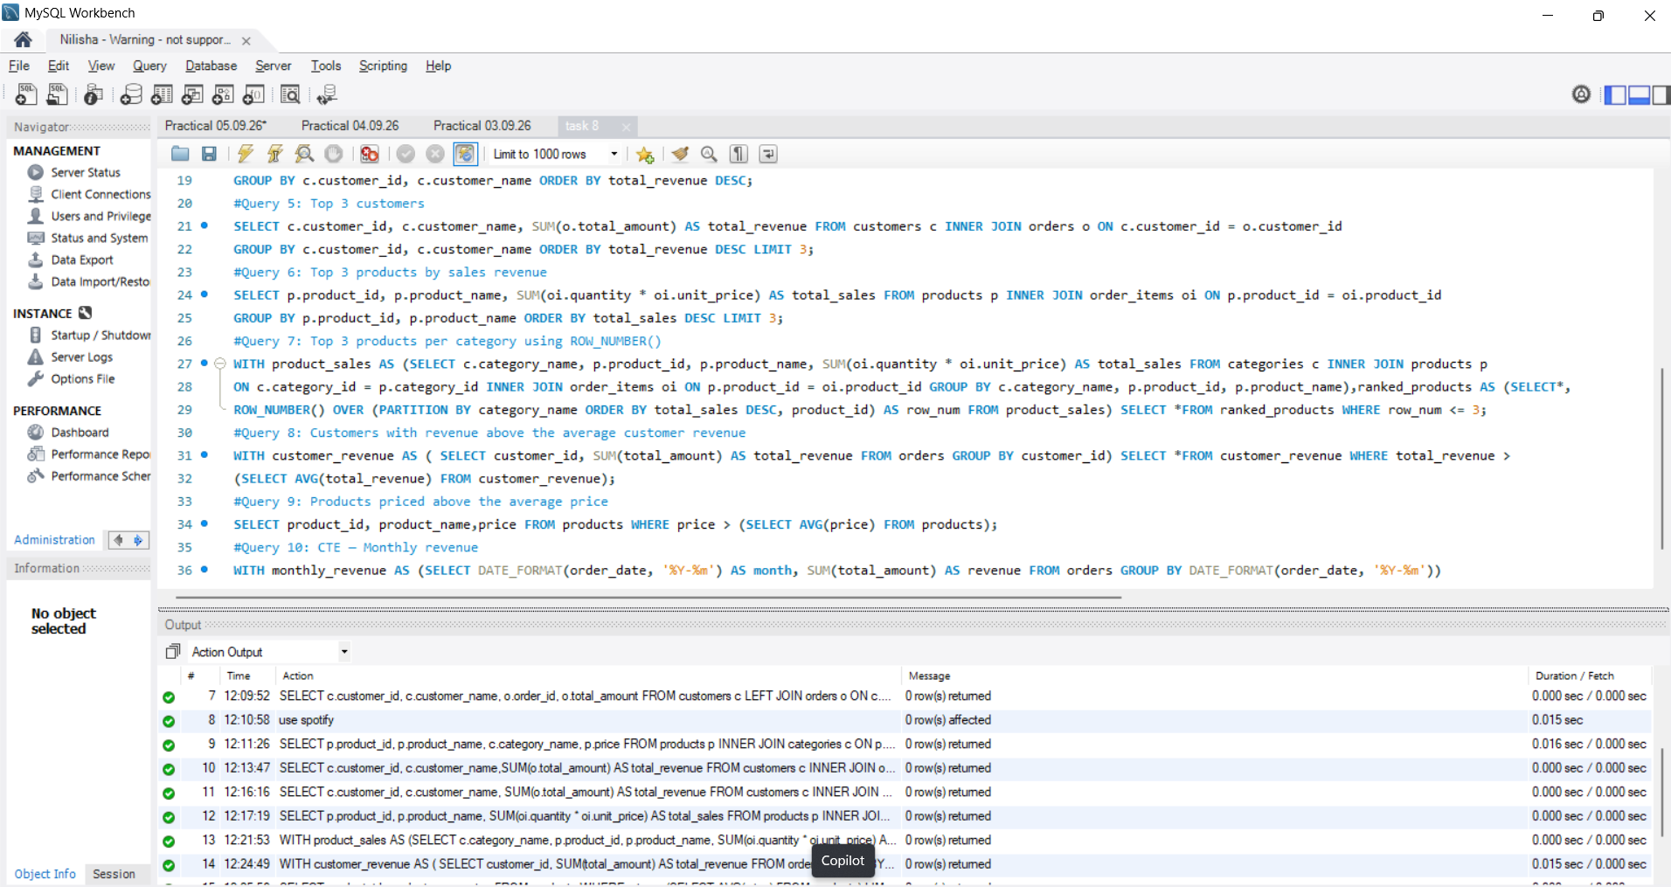

DAY 9 —:- Statistics -:
1) Task Day: Monday, Date :21/09/2026
2) Task Description: Learn and calculate statistical concepts such as Mean, Median, Mode, Range, Variance, Standard Deviation, Percentile, Quartile, IQR, Correlation, and Covariance using a dataset.
3) 2) Task Elaboration: 1. Calculated statistical measures such as Mean, Median, Mode, Range, Variance, Standard Deviation, Percentile, Quartile, and IQR using Python.
2. Analyzed Correlation and Covariance to understand relationships, data patterns, and insights from the dataset.
4) Task Screenshot / Proofs: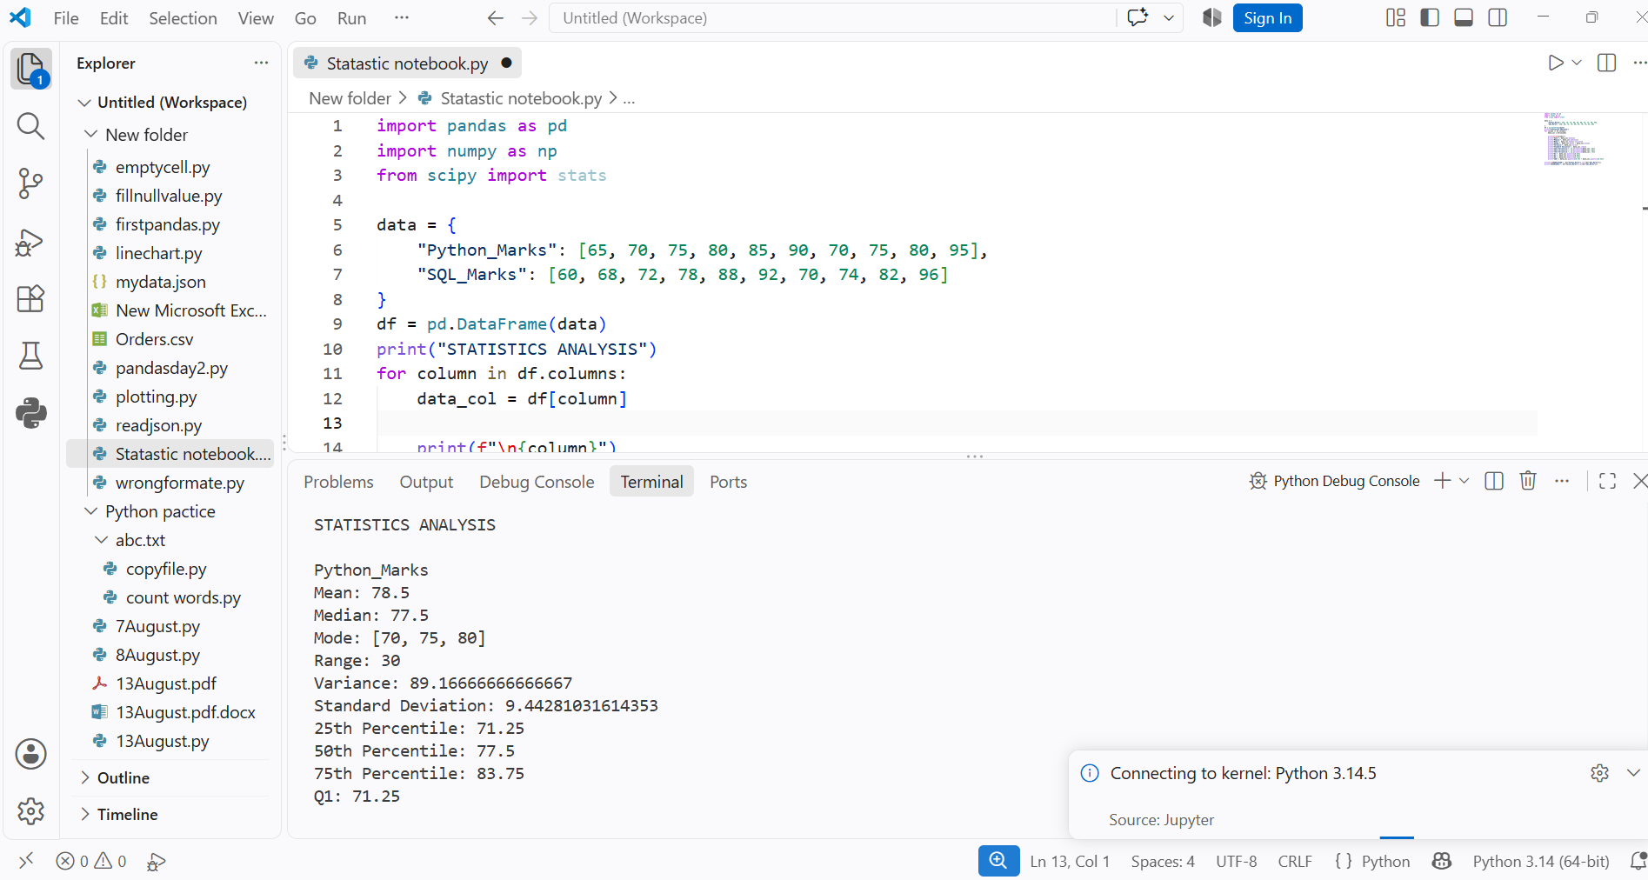
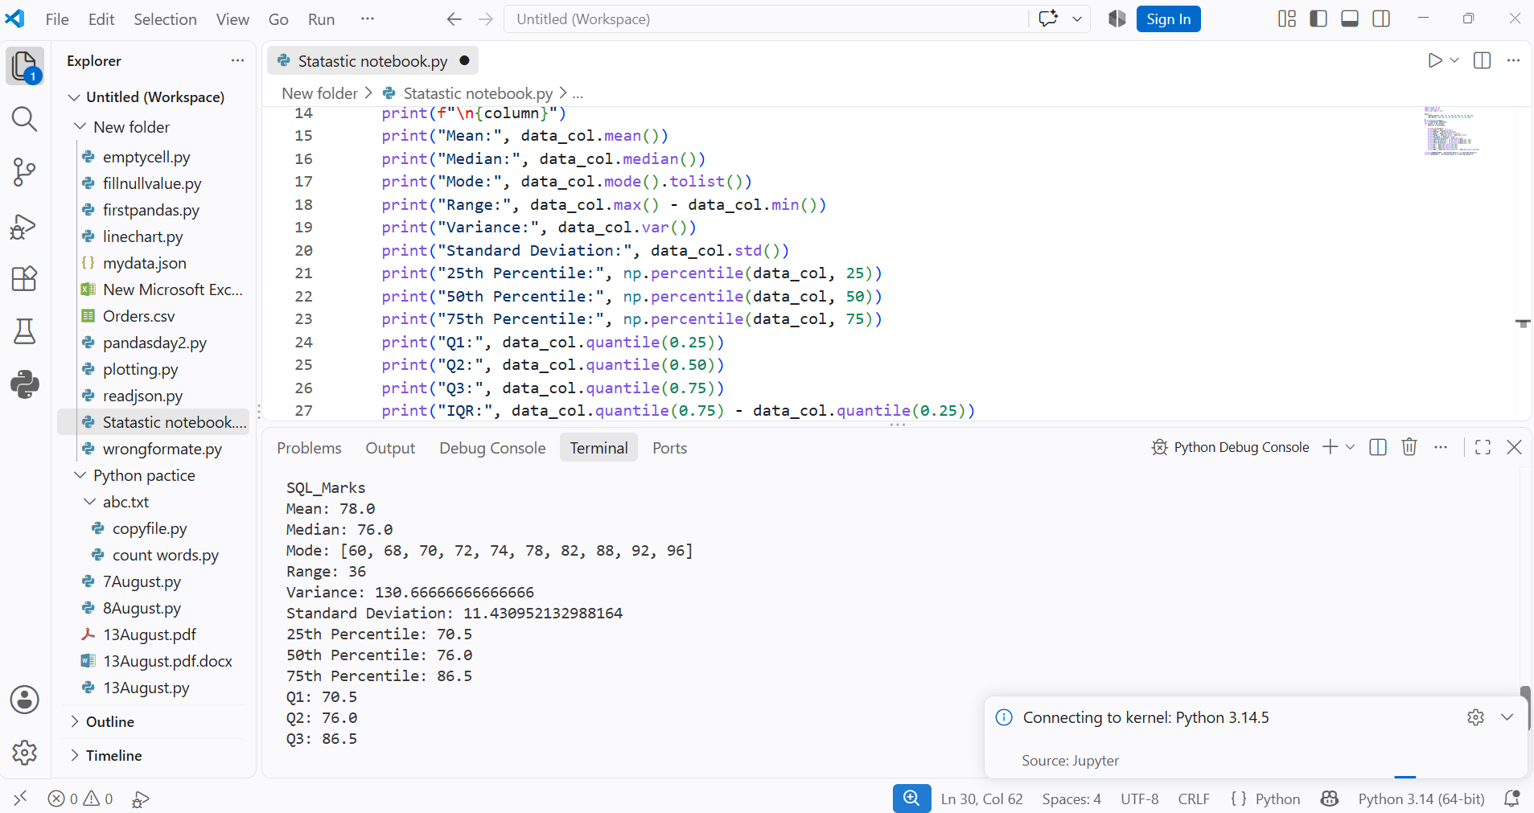
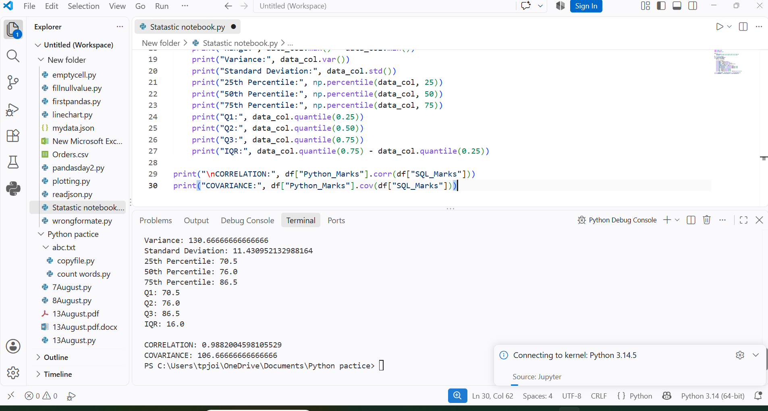
DAY 10 —:- Probability -:
1) Task Day: Wednesday, Date :23/09/2026
2) Task Description: Learn and implement probability concepts such as Probability, Conditional Probability, Independent Events, Dependent Events, Bayes' Theorem, Normal Distribution, and Binomial Distribution.
3) 2) Task Elaboration: 1) Solved 15 probability problems covering basic and advanced probability concepts. 2) Implemented 5 probability problems using Python to understand mathematical calculations and their applications in machine learning.
4) Task Screenshot / Proofs:
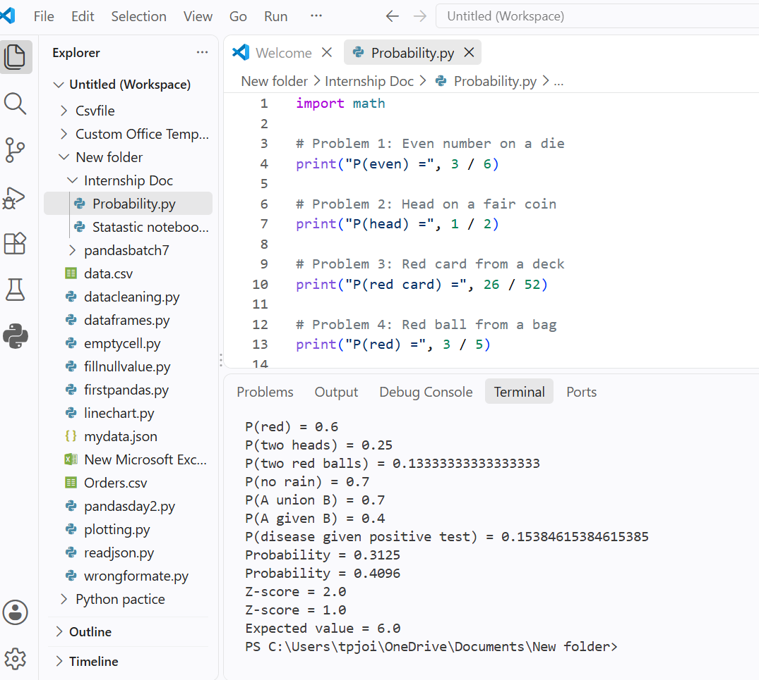

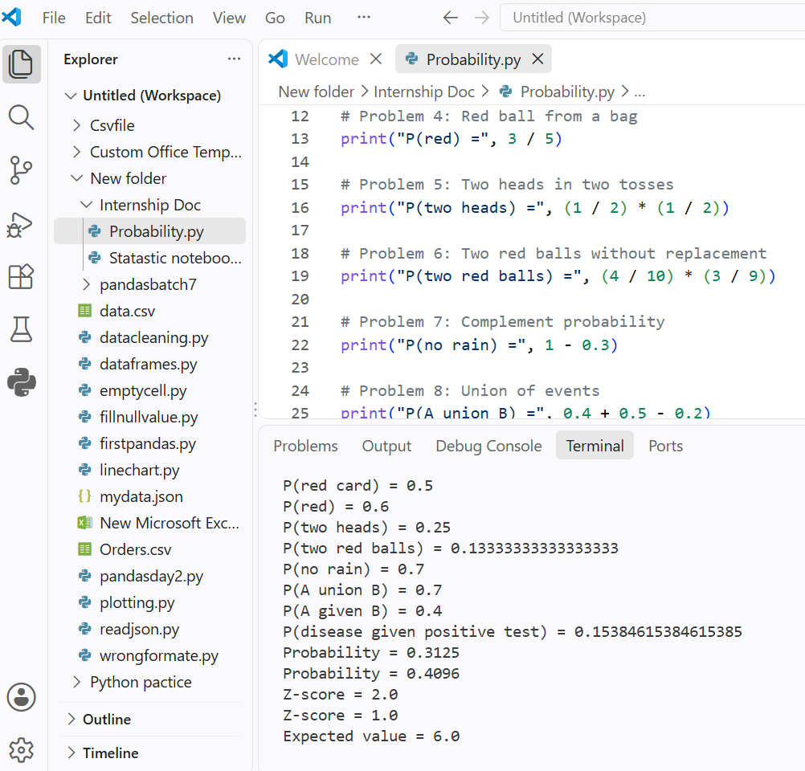
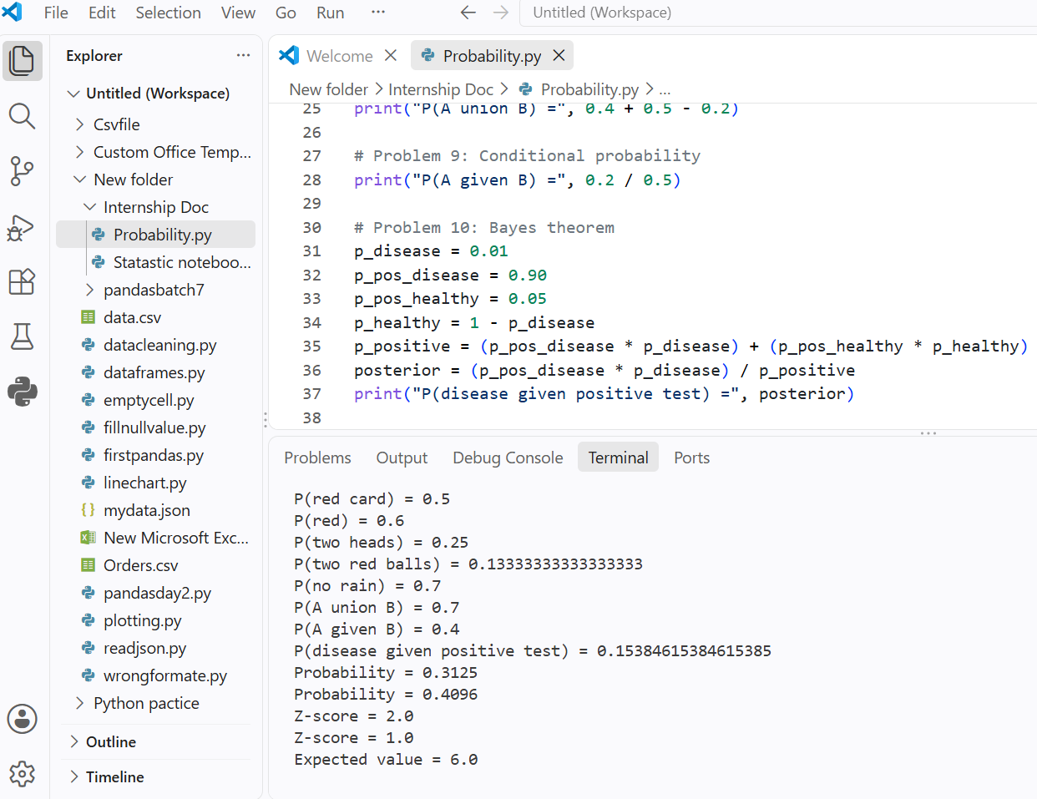
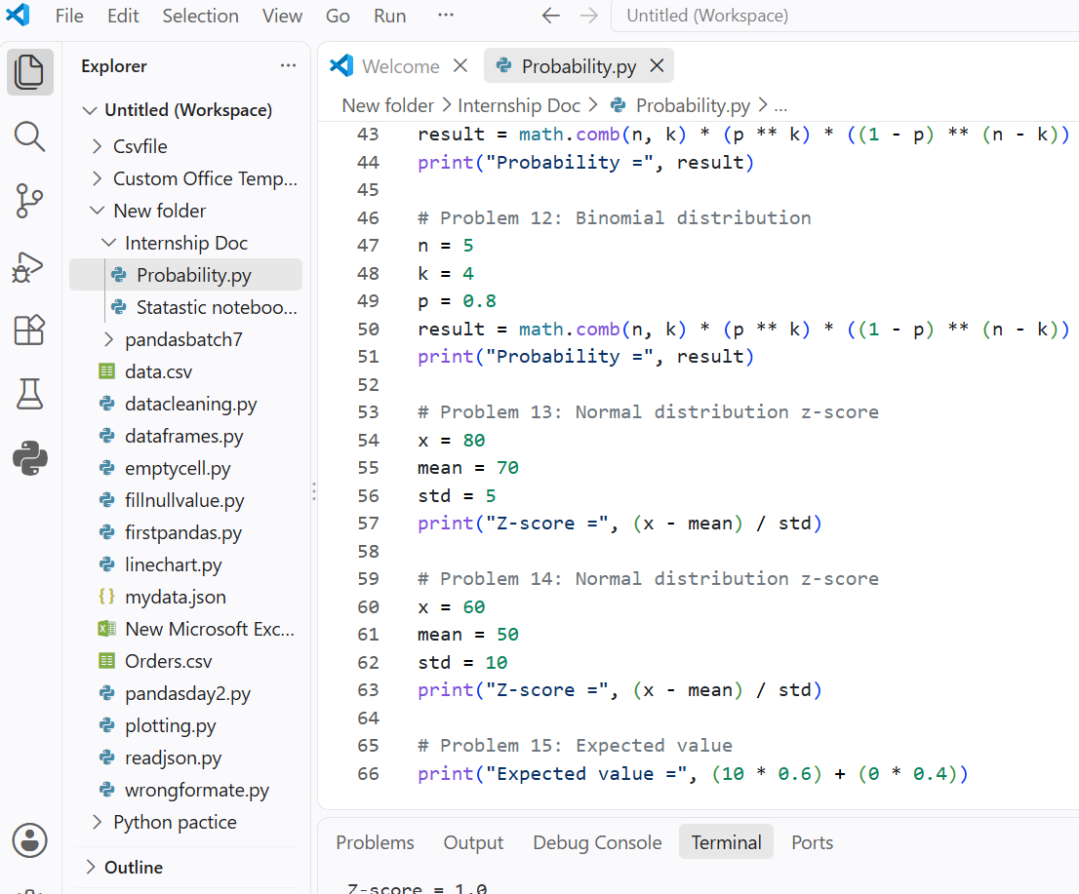
DAY 11 —:- Matplotlib Visualization 📊-:
1) Task Day: Thursday, Date :24/09/2026
2) Task Description: Learn Matplotlib and create at least 10 different charts using one dataset. Each chart includes a suitable title, axis labels where applicable, proper formatting, and an interpretation of the information displayed.
3) 2) Task Elaboration: 1) In this task, I learned how to use Matplotlib, Pandas, and NumPy for data visualization. 2) I created a sales dataset and used it to generate different charts for understanding business information.
4) Task Screenshot / Proofs:
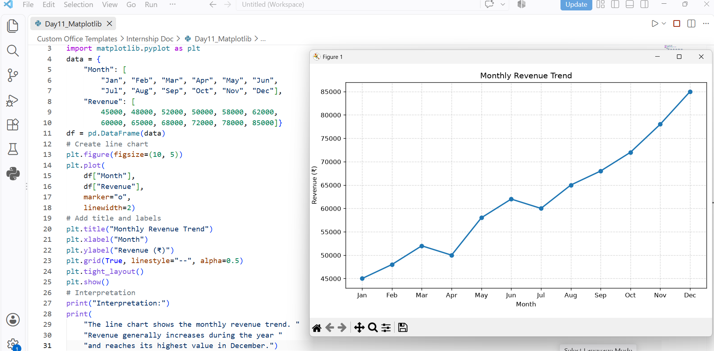

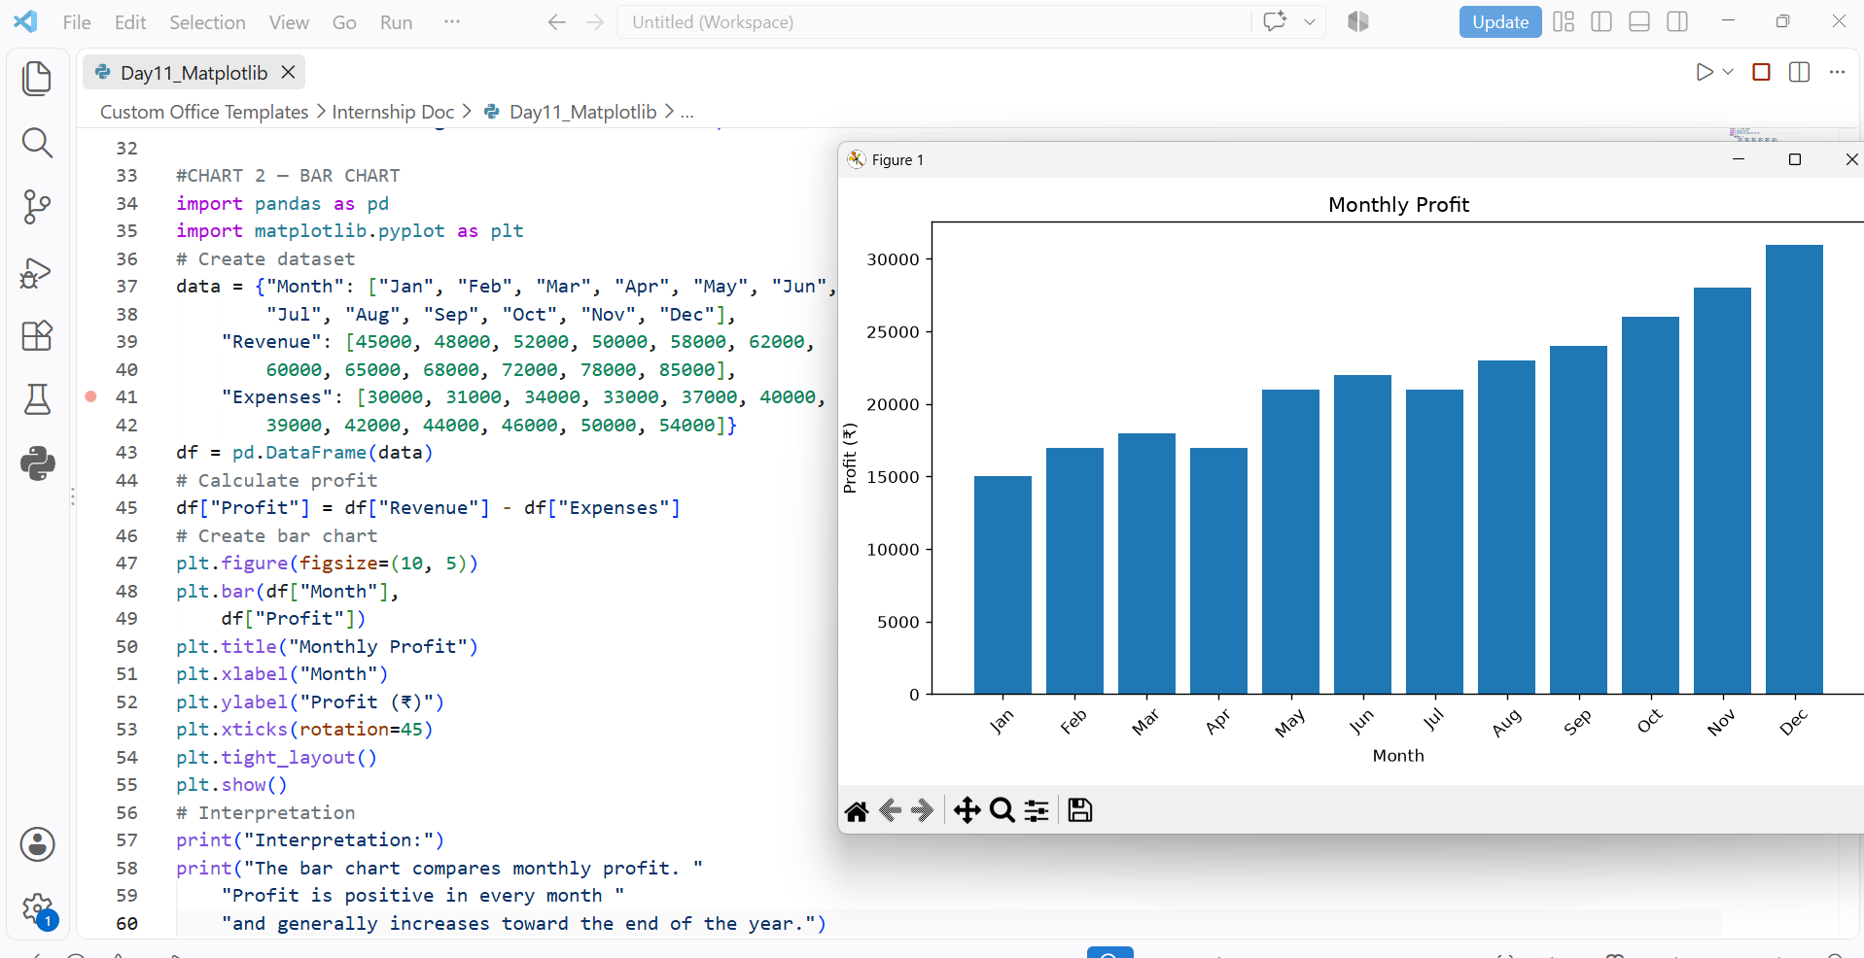

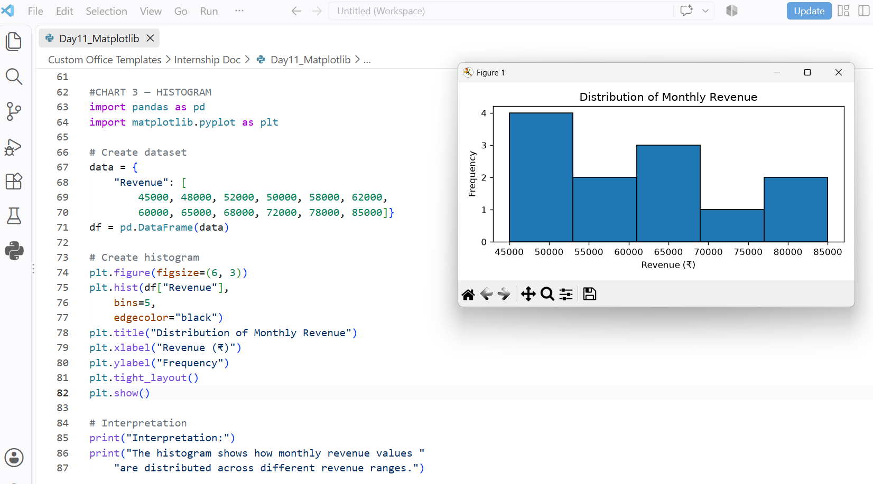

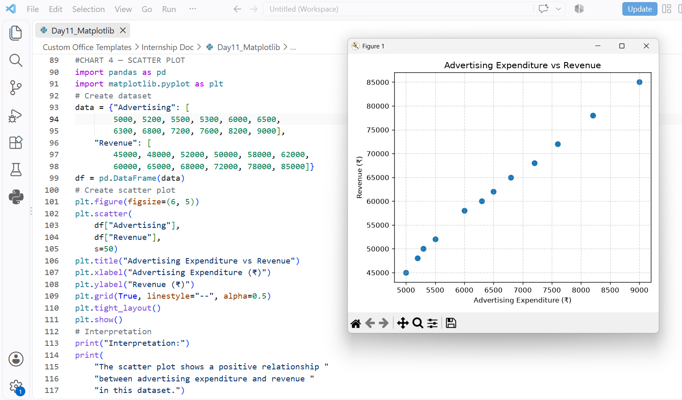

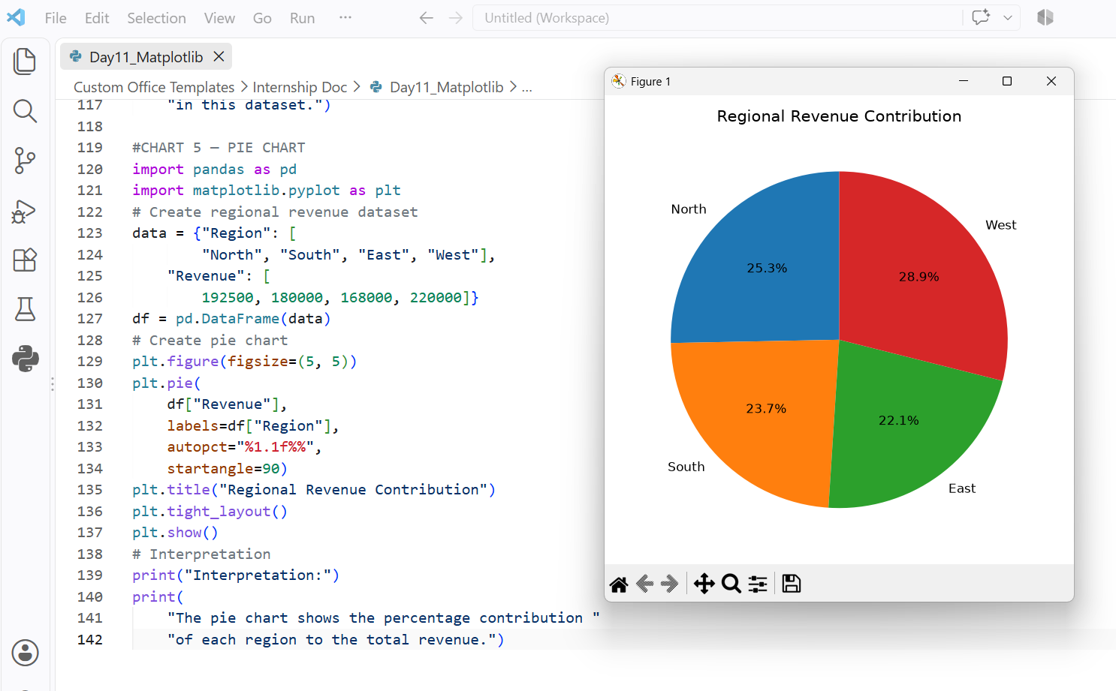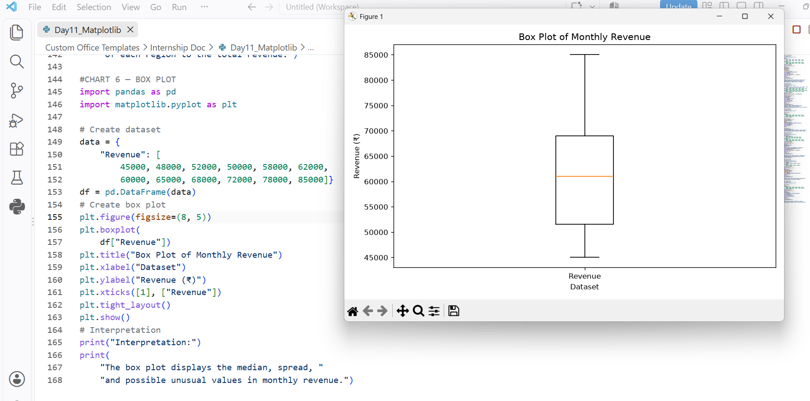
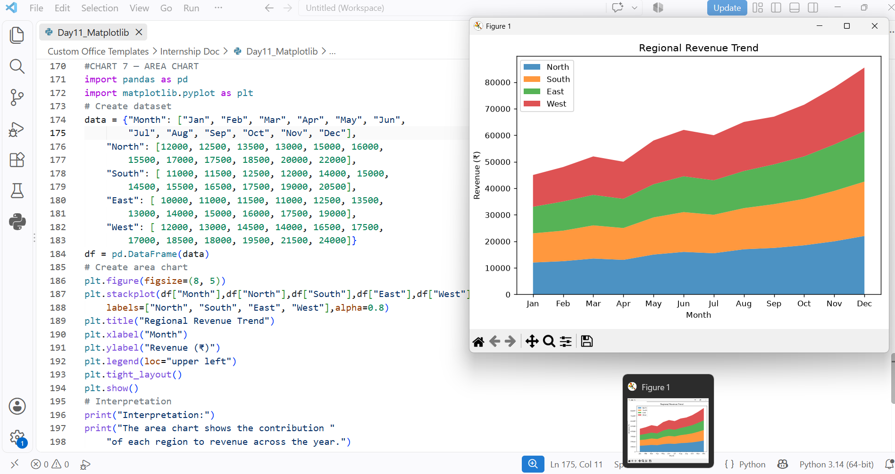

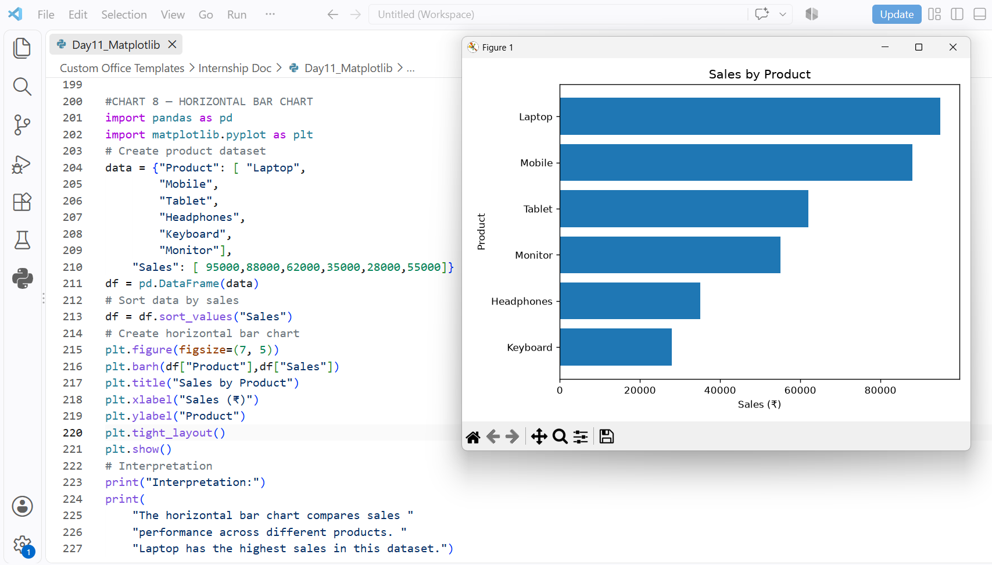

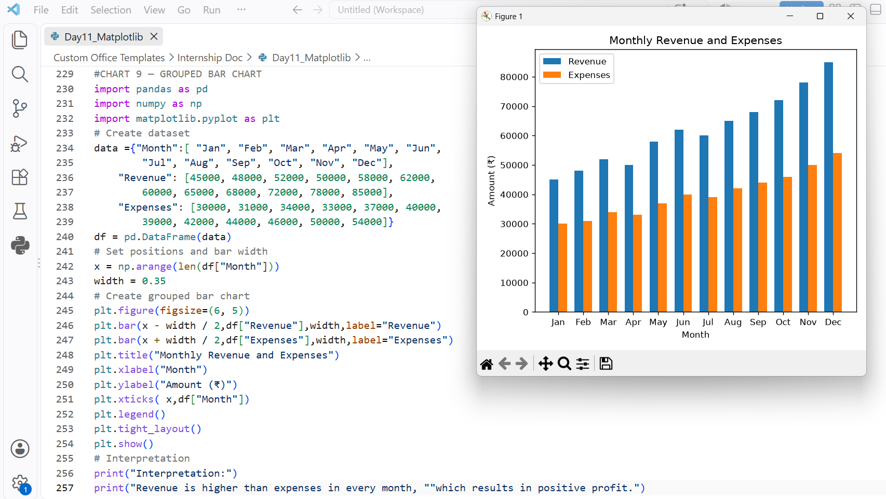
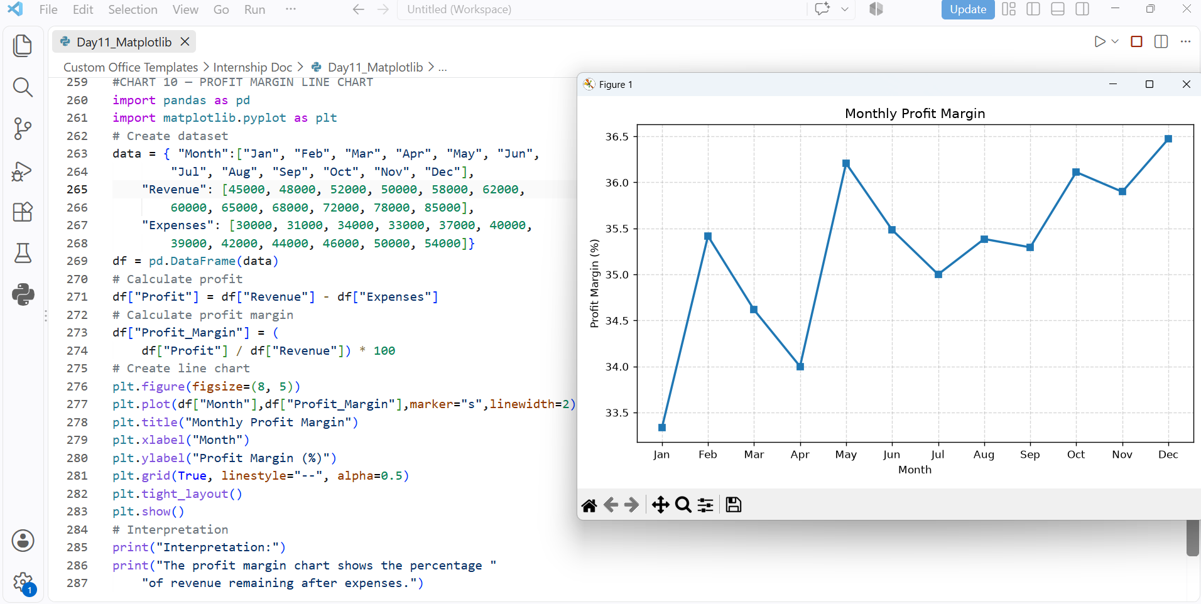
DAY 12 —:- Seaborn + Advanced EDA -:
1) Task Day: Thursday, Date :24/09/2026
2) Task Description: To perform Exploratory Data Analysis (EDA) using Python, Pandas, Matplotlib, and Seaborn. Analyze the dataset to identify patterns, trends, relationships, and outliers using advanced data visualization techniques.
3) Task Elaboration: 1) In this task, I learned how to perform Advanced Exploratory Data Analysis (EDA) using Python libraries such as Pandas, Matplotlib, and Seaborn. I explored the dataset, checked missing values, identified duplicate records, and understood the distribution of data.
2) I created different visualizations using Seaborn, including bar plots, histograms, box plots, scatter plots, heatmaps, and pair plots. These visualizations helped me understand relationships between variables, detect outliers, identify correlations, and discover important patterns in the dataset.

4) Task Screenshot / Proofs: 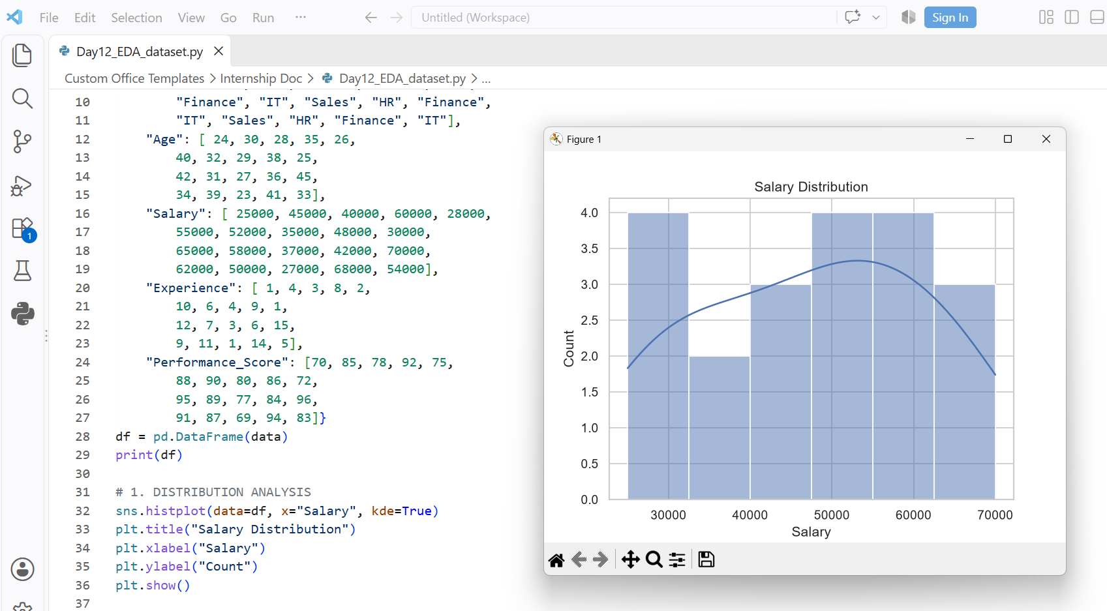
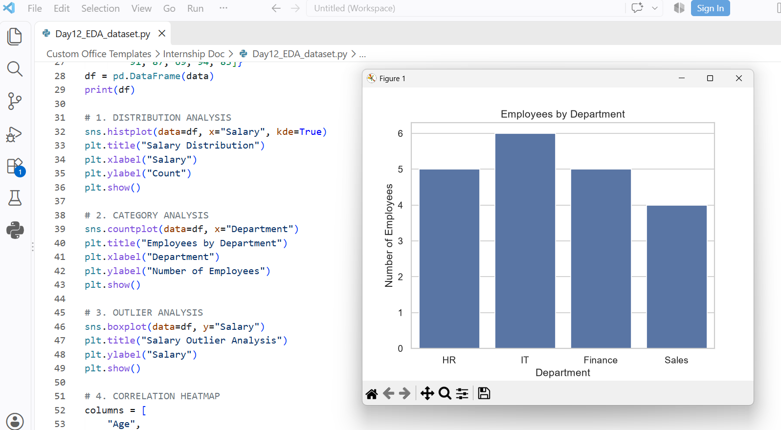
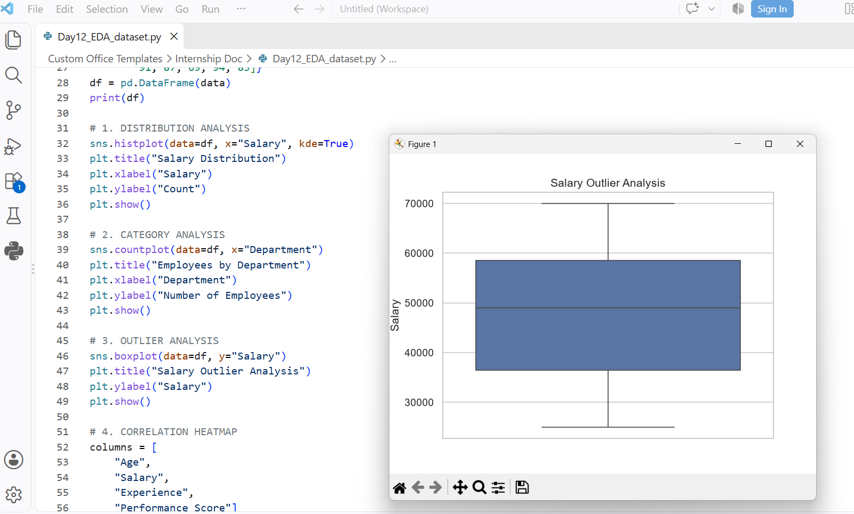
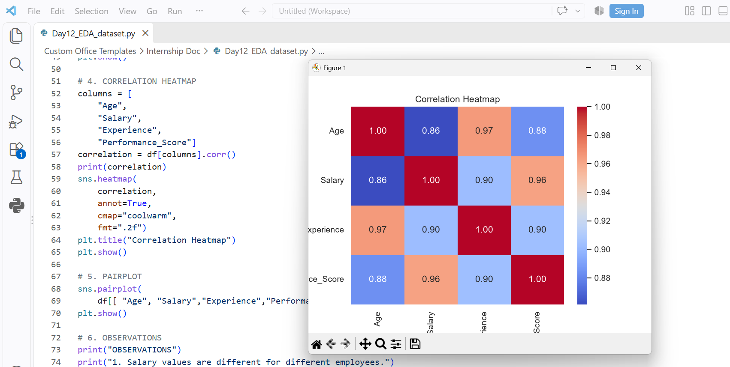
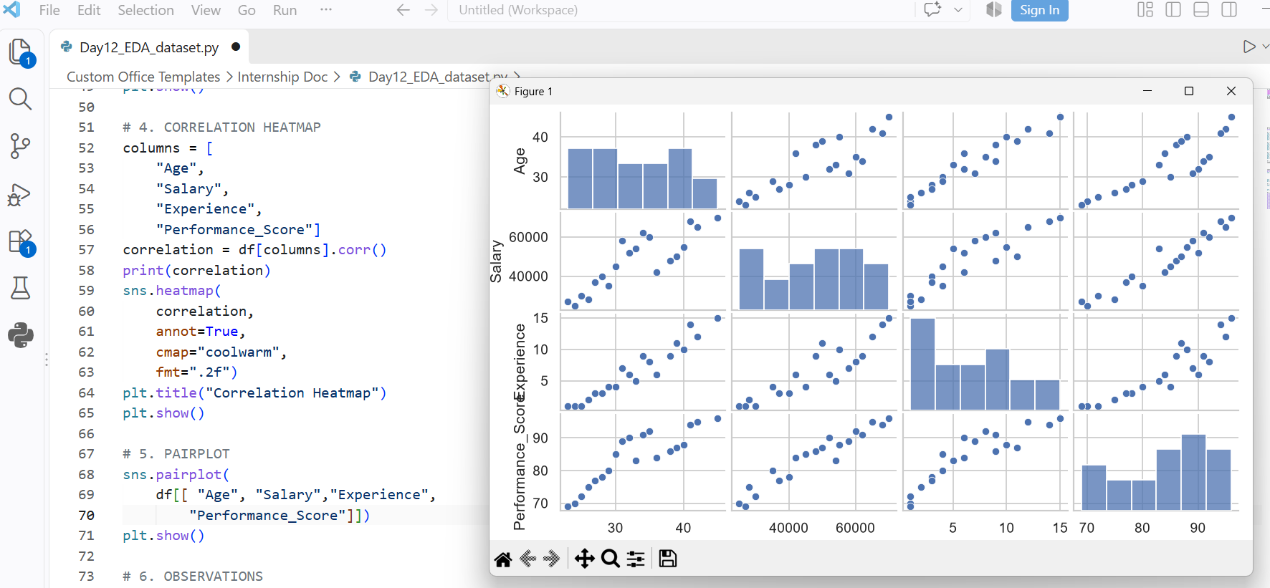
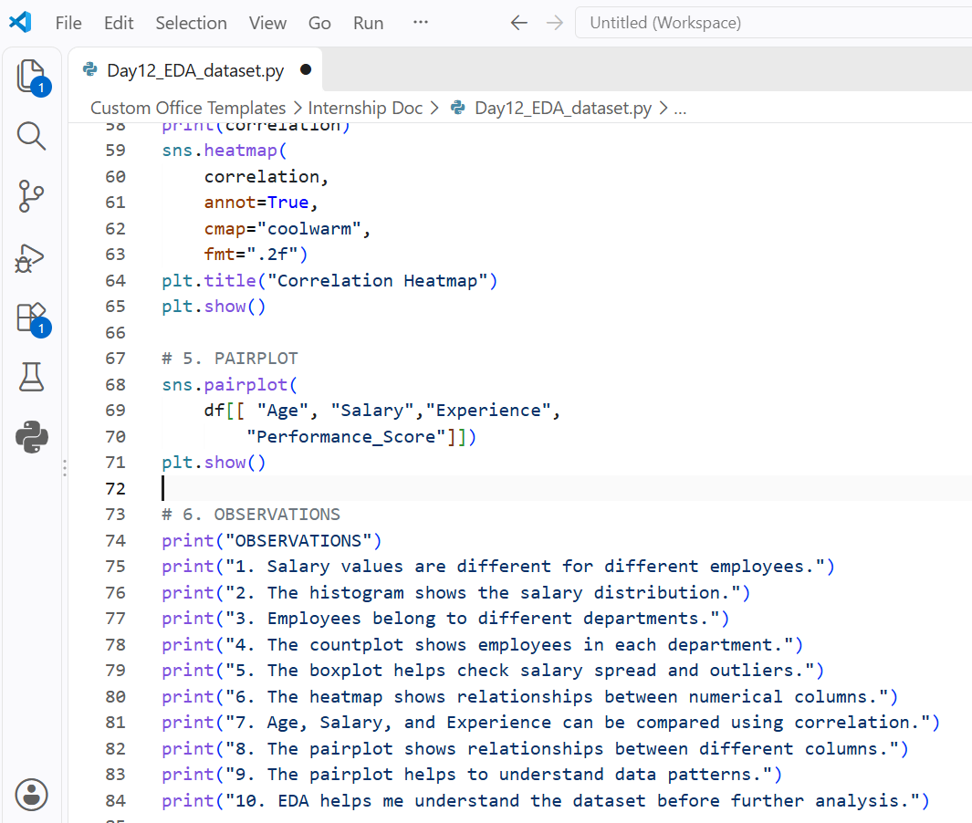

DAY 13 —:- Power BI -:
1) Task Day: Friday, Date :25/09/2026
2) Task Description: Learn Power BI and create a one-page Sales Dashboard using data import, Power Query, data transformation, filters, slicers, charts, cards, tables, and matrix visuals.
3) 2) Task Elaboration: 1) Imported the sales dataset into Power BI and used Power Query to clean and transform the data, including checking data types and preparing the required columns.
2) Created a one-page interactive Sales Dashboard containing Total Sales, Total Orders, Total Customers, Sales by Category, Sales by Region, and Monthly Sales using cards, charts, tables, filters, and slicers.
4) Task Screenshot / Proofs:
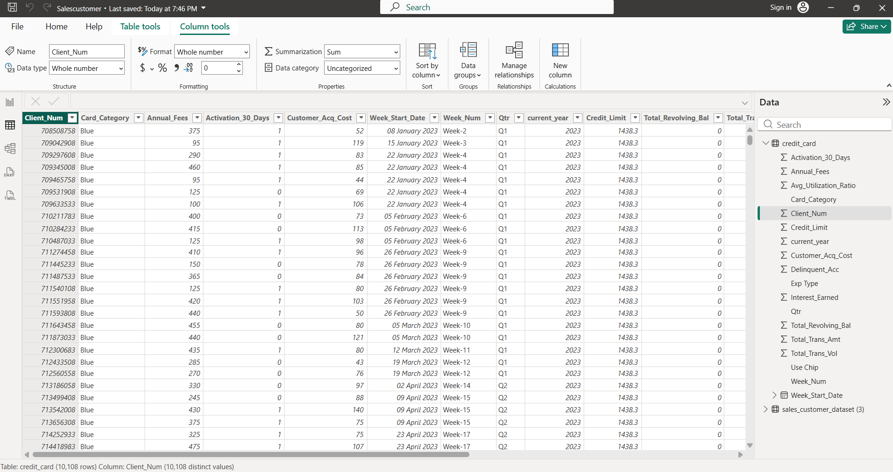
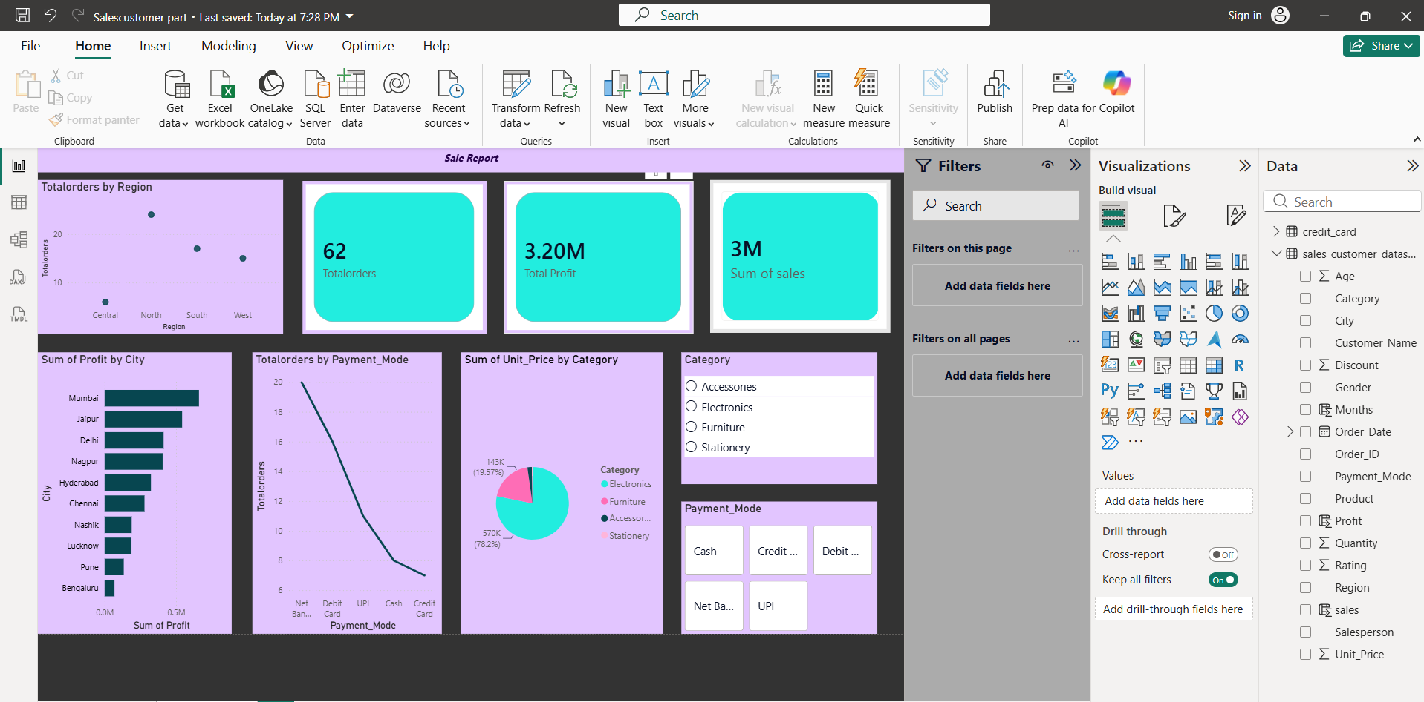

DAY 14 — :- DAX -:
1) Task Day: Friday, Date :25/09/2026
2) Task Description: Learn DAX (Data Analysis Expressions) and create measures for revenue, profit, orders, customers, average order value, and profit margin in Power BI.
3) 2) Task Elaboration: 1) Created DAX measures such as Total Revenue, Total Profit, Total Orders, Total Customers, Average Order Value, and Profit Margin, along with additional measures to meet the requirement of at least 8 measures.
2) Practiced important DAX functions including CALCULATE, FILTER, ALL, SUMX, COUNTROWS, and DISTINCTCOUNT to perform dynamic calculations and analysis in the Power BI dashboard.
4) Task Screenshot / Proofs:
